Fake News Detection Using Python and Machine Learning

Uttham Sing k | Sudharsan M | Yuvaraj D
Electronics and communication | Electronics and communication | Electronics and communication
Rajalakshmi Institute of Technology | Rajalakshmi Institute of Technology | Rajalakshmi Institute of Technology
Chennai, India | Chennai, India | Chennai, India
utthamsing.k.2021.ece@ritchennai.edu.in | sudharsan.m.2021.ece@ritchennai.edu.in | Yuvaraj.d.2021.ece@ritchennai.edu.

Abstract --- Fake news has emerged as a giant difficulty within the generation of records overload and social media proliferation. Detecting and preventing the spread of fake records is essential to maintain the integrity of news intake and keep public trust. Machine mastering techniques have received traction as a promising method for faux news detection due to their capacity to procedure big amounts of information and analyze styles indicative of fake information traits. This paper presents an overview of faux information detection the usage of system mastering, highlighting the important thing demanding situations, strategies, and current advancements in the subject. We speak the importance of categorized
access even the most vital information that can even sometimes be life- changing or lifesaving

Machine learning provides a powerful framework for analyzing large amounts of data and extracting patterns that can help differentiate between real and fake news. By training a machine learning model on a dataset of labeled news articles, it can learn to recognize patterns and features indicative of fake news. Python, with its extensive libraries and tools for machine learning, makes it an ideal choice for implementing such models. Detecting fake news involves analyzing the content and identifying the characteristics that distinguish it from reliable and trustworthy information.

education information, feature extraction methods, and diverse machine gaining knowledge of algorithms hired for type
obligations. We additionally discover the effect of opposed attacks,

contextual understanding, and bias mitigation at the accuracy of detection models. Furthermore, we discuss the moral considerations and privacy implications related to the implementation of gadget studying-primarily based faux news detection structures. Through an exam of present day studies tendencies and sensible issues, this paper aims to provide insights and guidance for researchers and practitioners within the pursuit of effective faux information detection solutions using machine mastering.

INTRODUCTION

Fake News is news, stories, or hoaxes created to deliberately misinform or deceive readers. Usually, these stories are created to either influence people’s views, push a political agenda, or cause confusion and can often be a profitable business for online publishers. The purpose of choosing this topic is because it is becoming a serious social challenge. It is leading to a poisonous atmosphere on the web and causing riots and lynching on the road. Examples: political fake news, news regarding sensitive topics such as religion, covid news like salt and garlic can cure corona and all such messages we get through social media.
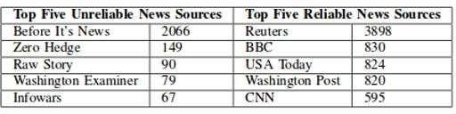
We all can see the damage that can be caused because of fake news which is why there is a dire need for a tool that can validate particular news weather it is fake or real and give people a sense of authenticity based on which they can decide whether or not to take action, amongst so much noise of fake news and fake data if people lose faith in information, they will no longer be able to

LITERATURE SURVEY

We have defined fake news and presented some fundamental theories in various disciplines. We detailed the detection of fake news from four perspectives : Knowledge based methods, which detect fake news by verifying if the knowledge within the news content is consistent with facts Style-based methods are concerned with how fake news if it is written with extreme emotions, Propagation based methods, where they detect fake news based on how it spreads online and Source based methods detect fake news by investigating the credibility of the sources at various stages being created, published online, and spread on social media. We also discuss open issues in current fake news studies and in fake news detection. Later details about how fake news is related to terms such as deceptive news, false news, satire news, disinformation, misinformation, cherry-picking, click bait, and rumor. Compared to other related surveys that often provide a specific definition for fake news, this survey highlights the challenges of defining fake news and introduces both a narrow and a broad definition for it. Though the recent studies have highlighted the importance of multidisciplinary fake news research, we provide a path towards it by conducting an extensive literature survey across various disciplines, identifying a comprehensive list of well-known theories. I have demonstrated how these theories relate to fake news and its spreaders and illustrate technical methods utilizing these theories both in fake news detection and intervention. For fake news detection, current surveys have mostly limited their scope to reviewing research from a certain perspective or within a certain research area, e.g., NLP and data mining. These surveys generally classify fake news detection models by the types of deep machine learning methods used or by whether they utilize social context information. We have four perspectives: knowledge, style, propagation and source. Reviewing and organizing fake news detection studies in such a way it allows analyzing both news content and the medium often, social media on which the news spreads, where fake news detection can be defined as a probabilistic regression problem linked to entity resolution and

prediction of tasks is linked, or as classification problem that relies on feature engineering and text, graph embedding techniques. In our survey of fake news detection, patterns of fake news in terms of its content or how it propagates are revealed, algorithms and model architectures are presented, and comparison of performance of various fake news detection methods. We point out that the survey focuses more on how to construct a fake news dataset like ground truth data, and the possible sources to obtain such ground truth, other than detailing existing datasets, which have been already provided in past surveys.

OBJECTIVE

The objective of fake news detection using machine learning is to develop algorithms and models that can automatically identify and classify misleading or false information in news articles, social media posts, and other online content. The primary goal is to distinguish between reliable, fact-based news and fabricated or misleading information in order to help users make informed decisions and prevent the spread of misinformation.

The key objectives of fake news detection using machine learning include:

- Classification: Developing accurate classification models that can differentiate between genuine news and fake news based on various features such as textual content, metadata, source credibility, and user engagement.

- Feature Extraction: Identifying relevant features and extracting meaningful patterns from the textual content, including linguistic cues, sentiment analysis, syntactic structures, and semantic representations that can help distinguish between reliable and unreliable information.

- Training Data: Building large and diverse datasets of labeled news articles and social media posts, including both authentic and fake examples, to train machine learning models. This involves manual annotation or leveraging existing labeled datasets.

- Model Training: Utilizing machine learning algorithms such as supervised learning, natural language processing (NLP), deep learning, and ensemble methods to train models on the labeled datasets. These models learn to recognize patterns indicative of fake news and make accurate predictions on new, unseen data.

- Model Evaluation: Assessing the performance and effectiveness of the trained models by measuring metrics such as accuracy, precision, recall, and F1-score. This evaluation helps determine the model's ability to correctly classify fake news and minimize false positives or false negatives.

- Real-Time Detection: Implementing the trained models in real-time applications to automatically identify
and flag potential instances of fake news as they emerge on social media platforms, news websites, or other online sources.
By achieving these objectives, the aim is to enhance media literacy, support journalists, and empower users to critically evaluate the information they encounter, thereby mitigating the impact and spread of fake news in the digital landscape.

OUTCOMES

Fake news detection using machine learning has made significant strides in recent years. With the availability of large labeled datasets and advancements in natural language processing techniques, machine learning models have become increasingly effective in identifying and flagging fake news. Here is a brief outcome for fake news detection using machine learning:

- Increased Accuracy: Machine learning models trained on large datasets have achieved higher accuracy rates in identifying fake news articles. These models can analyze various linguistic and contextual features, such as misleading headlines, biased language, unreliable sources, and inconsistencies, to determine the authenticity of a news article.

- Efficient Filtering: Fake news detection algorithms can efficiently filter through vast amounts of information, quickly flagging suspicious articles and reducing the burden on human fact-checkers. This helps prevent the spread of misinformation on social media platforms and news websites.

- Real-Time Detection: Machine learning models can operate in real-time, enabling instant detection and classification of fake news articles as they are published. This feature is crucial in today's fast-paced digital landscape, where false information can spread rapidly and cause harm before it can be addressed.

- Continuous Learning: Machine learning models can continuously learn and adapt to new types of fake news. By leveraging techniques such as transfer learning and active learning, these models can improve their accuracy over time, becoming more adept at identifying sophisticated techniques used to deceive readers.

- User Empowerment: Fake news detection tools can be integrated into web browsers, social media platforms, and news aggregators, empowering users to make informed decisions about the information they consume. These tools provide users with warnings or labels when they encounter potentially false or misleading content, fostering critical thinking and media literacy.

- Collaboration with Human Fact-Checkers: Machine learning models complement the work of human fact-checkers by automating initial screening and identifying potentially false articles. This
collaboration between humans and machines enhances the efficiency and effectiveness of the fact checking process.

While machine learning has significantly improved fake news detection, it is important to note that it is not a foolproof solution. The evolving nature of fake news requires continuous research and development to stay ahead of the techniques employed by purveyors of misinformation. Moreover, ethical considerations and potential biases within the training data and algorithms must be carefully addressed to ensure fair and accurate results.

. V. CHALLENGES

Fake news detection using machine learning faces several challenges that researchers and practitioners must address. Here is a brief note on some of the key challenges:

- Lack of Labeled Training Data: Machine learning models require large amounts of labeled data for training. However, obtaining a comprehensive and accurately labeled dataset of fake news articles can be challenging. It often requires human experts to manually annotate the data, which can be time- consuming and subjective.

- Adversarial Attacks: Malicious actors can deliberately manipulate or craft news articles to deceive machine learning models. Adversarial attacks, such as injecting subtle changes or using advanced evasion techniques, can bypass the detection algorithms. Developing robust models that are resistant to such attacks is a constant challenge.

- Contextual Understanding: Fake news often relies on subtle nuances, linguistic tricks, and contextual understanding to appear credible. Capturing and interpreting this context accurately is a complex task for machine learning models. Contextual understanding involves analyzing the credibility of sources, evaluating the coherence of claims, and detecting semantic inconsistencies.

- Swift Evolution of Techniques: Those who create fake news are constantly evolving their strategies and techniques to deceive both humans and machine learning models. New tactics emerge regularly, such as deepfake videos, AI generated content, and sophisticated social engineering. Keeping up with these evolving techniques and adapting detection models accordingly is an ongoing challenge.

- Bias and Generalization: Machine learning models can inadvertently inherit biases from the training data. If the training dataset contains biased information, the model may exhibit biased behavior when detecting fake news. Ensuring fairness, reducing bias, and improving generalization across different domains and languages are ongoing challenges in the field.

- Privacy and Ethics: Fake news detection often involves analyzing large amounts of user data, such as browsing history
and social media interactions. Balancing the need for effective detection with user privacy and ethical considerations is a significant challenge. Developing privacy- preserving techniques and adhering to strict ethical guidelines is crucial.

Addressing these challenges requires interdisciplinary collaboration, including experts in machine learning, natural language processing, journalism, and social sciences. Ongoing research, access to diverse and representative datasets, and regular evaluation of detection models are essential to improving the effectiveness and reliability of fake news detection using machine

ARCHITECTURE

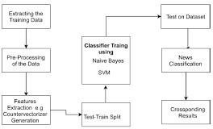

Architecture flow Fake news detection model:
False proofing using machine learning faces several challenges that researchers and practitioners have to deal with. Here is a brief overview of some of the major
challenges.

  - Lack of labeled training data: Machine learning models require a lot of labels for training. However, finding detailed and accurate fake news can be difficult. Human experts often have to write specifications by hand, which can be time consuming and subjective.

  - Adversary attacks: Malicious actors may intentionally manipulate or create media to fool machine learning models. Adversary attacks, such as the introduction of subtle changes or the use of sophisticated selection techniques, can bypass detection mechanisms. Developing robust models that resist such attacks is an ongoing challenge.

  - Understanding context: Fake news often relies on subtle nuances, linguistic deception and contextual understanding to appear believable. Capturing and accurately interpreting this context is a challenging task for machine learning models. Understanding context involves assessing the credibility of sources, assessing consistency, and searching for inconsistencies.

  - Agile techniques: Counterfeiters are constantly changing their tactics and techniques to deceive humans and machine learning models. New channels are constantly emerging, including indepth videos, AI-powered content, and sophisticated social engineering. Keeping pace with these
evolving trends and adjusting detection models accordingly is an ongoing challenge.

  - Bias and generalization: Machine learning models can inadvertently get biased from training data. If the training data set contains biased information, the model may be exposed.

IMPLEMENTATION :

Implementing fake news detection using system getting to know includes several steps. Here is a quick be aware on the important thing components of enforcing this kind of system:

- Data Collection: Gather a various and representative dataset comprising both genuine and pretend information articles. This dataset ought to be classified to suggest the authenticity of each article.
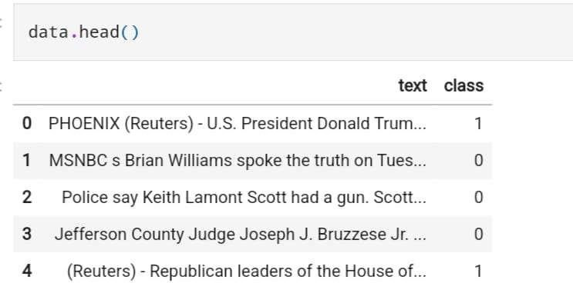

- Data Preprocessing: Clean the amassed facts by way of doing away with noise, beside the point records, and formatting inconsistencies. Convert the textual records right into a appropriate layout for in addition analysis, which includes tokenization and normalization.
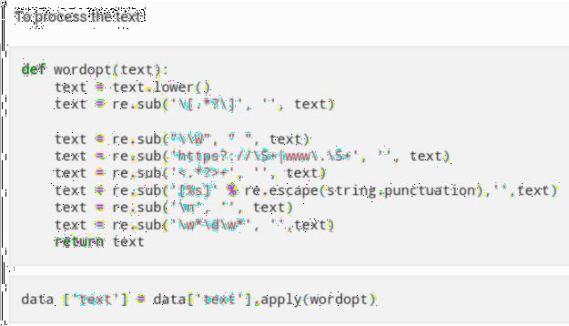

- Feature Extraction: Extract applicable features from the preprocessed information to capture crucial characteristics of faux information. These capabilities can encompass lexical, syntactic, semantic, and contextual facts. Techniques like TF-IDF, word embedding, or advanced language fashions (e.g., BERT) can be used for feature extraction.

- Model Selection: Choose the right machine getting to know set of rules for faux information detection.
Commonly used algorithms consist of logistic regression, aid vector machines (SVM), random forests, or neural networks. Consider the unique necessities of the trouble, along with interpretability, scalability, and real-time processing.

- Model Training: Split the dataset into schooling and testing units. Train the selected system studying model the use of the training set, using the extracted features as enter and the categorized authenticity as the goal variable. Adjust hyper parameters, such as studying price, regularization, or community structure, to optimize the model's performance.
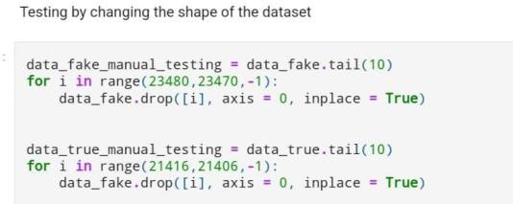

- Model Evaluation: Evaluate the skilled model the usage of the checking out set to degree its accuracy, precision, take into account, and F1 rating. Use suitable assessment metrics based totally on the hassle's necessities. Cross validation or holdout validation also can be carried out to assess the model's generalization and robustness.
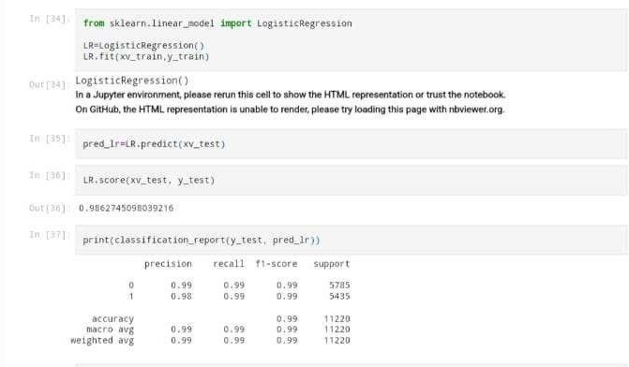

- Fine-tuning and Optimization: Iterate on the version through satisfactory-tuning hyper parameters, adjusting the function set, or exploring ensemble strategies to improve overall performance. Address any shortcomings or limitations recognized all through the assessment segment.

- Deployment and Integration: Integrate the educated version into a sensible utility or platform where faux information detection is required. This can include integrating the version into internet browsers, social media systems, or information aggregators to provide actual-time
detection and alert customers approximately potentially faux news articles.

- Continuous Monitoring and Updates: Maintain and monitor the deployed model to make sure its effectiveness over time. Keep track of emerging faux information strategies, replace the dataset, and retrain the model periodically to conform to evolving tendencies and new challenges.
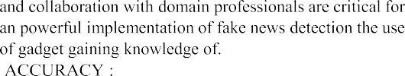
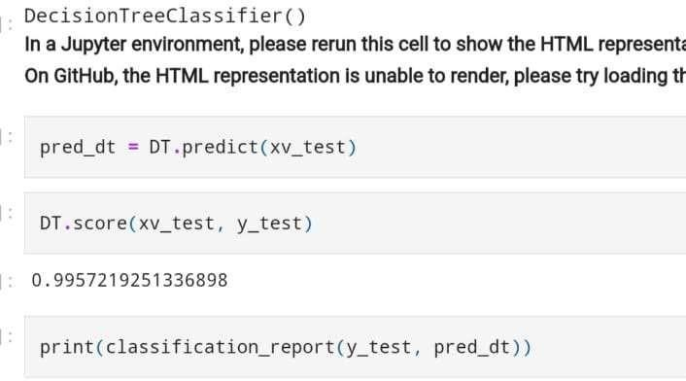
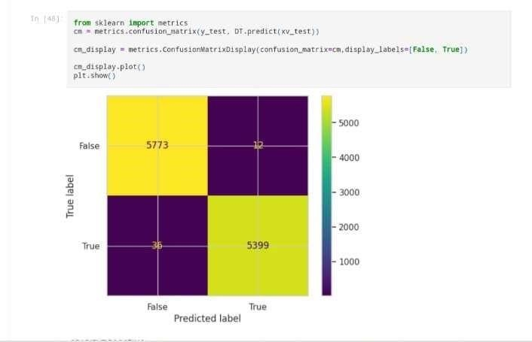
It's critical to note that fake information detection is a complicated and evolving hassle, and a single implementation might not be able to capture all elements. Regular research, staying up to date with new techniques,
10.
The accuracy of fake news detection using machine learning is an essential evaluation metric to measure the performance of detection models. It represents the proportion of correctly classified articles as either genuine or fake.

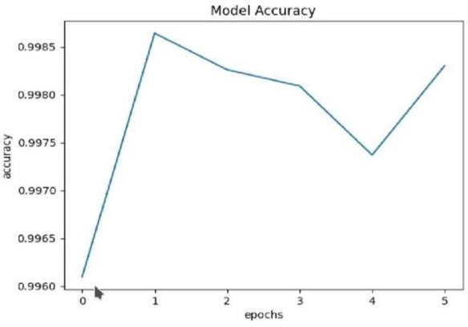

11. RESULTS : The classification accuracy for true news articles and false news articles is roughly the same, but classification accuracy for fake news is slightly deviated. By using the confusion matrix and the classification report further the accuracy of each individual model is measured.
 | Predicted:NO | Predicted:YES
Actual: NO | 5773 | 12
Actual: YES
36
5399
  - REFERENCE PAPERS :

- "Leveraging Social Connections to Improve Fake News Detection" by Shu et al. (2019)

URL:
https://dl.acm.org/doi/abs/10.1145/3336191.3371773

- "Fighting Fake News: Image Splice Detection via Learned Self-Consistency" by Li et al. (2020)

URL: https://arxiv.org/abs/2004.03078

- "Detection of Fake News in Social Media: A Data Mining Perspective" by Castillo et al. (2011)

URL:
https://dl.acm.org/doi/abs/10.1145/1963405.1963500

- "A Survey of Fake News: Fundamental Concepts, Detection Methods, and Opportunities" by Karimi et al.
(2020)

URL: https://arxiv.org/abs/2004.01074

- "Fake News Detection on Social Media: A Data Mining Perspective" by Shu et al. (2017)
URL: https://dl.acm.org/doi/abs/10.1145/3097983.3098091

- "Combating Fake News: A Survey on Identification and Mitigation Techniques" by Gianmarco De Francisci Morales, Luca Luceri, and Alessandro Lulli.
(Link: https://arxiv.org/abs/1812.00315)

- "Fake News Detection on Social Media: A Review" by Srijita Ghosh and Niloy Ganguly.
(Link: https://arxiv.org/abs/1902.06673)

- "Fake News Detection Using Machine Learning: A Systematic Literature Review" by Muhammad Faizan, Muhammad Usama, and Usman Qamar.

(Link: https://link.springer.com/article/10.1007/s00521-021- 06303w)

- ”Fake News Detection on Social Media: A Survey” by
Charalambos Chelmis, Shangsong Liang, Miao Liu, and
Michelle Lee. (Link: https://arxiv.org/abs/2007.00110)

- "Leveraging Graph Convolutional Networks for Fake News Detection" by Srijan Bansal, Aditya Chetan, and Manish
Gupta. (Link: https://arxiv.org/abs/2008.01216)

